Name: Gaurav Dhavale

NetId: gdd160130

**Data Model**

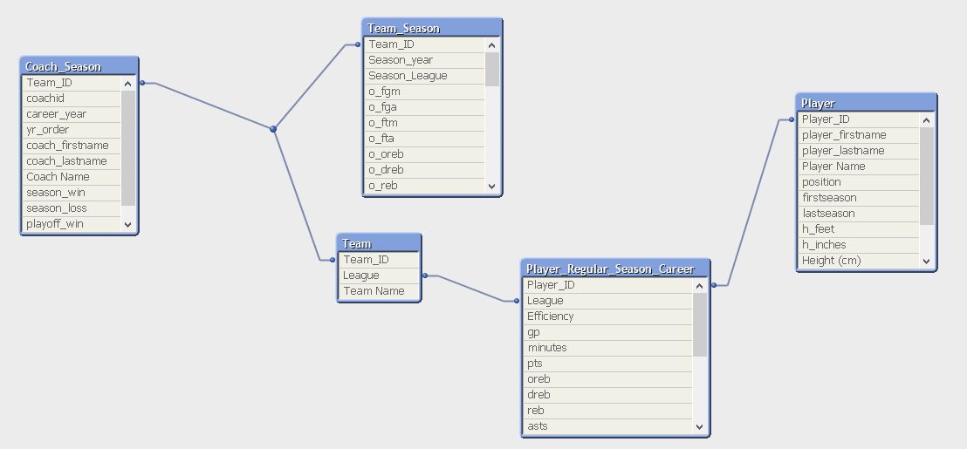

**Visualization**

**Dashboard:**

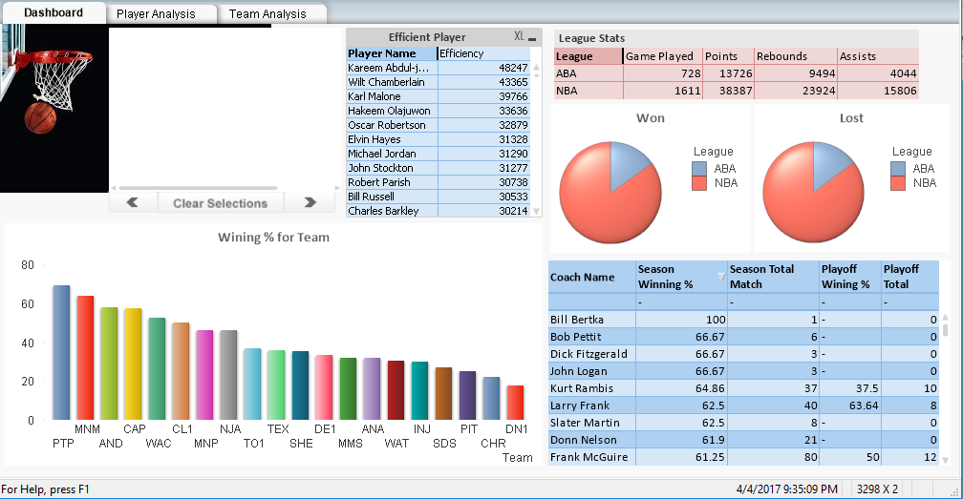

**Player Analysis**

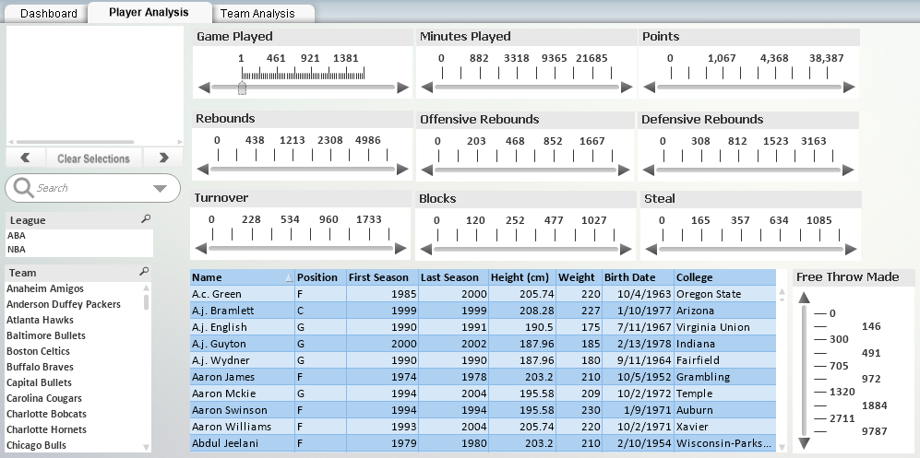

**Team Analysis**

